Let’s consider an example to calculate Betweenness Centrality:

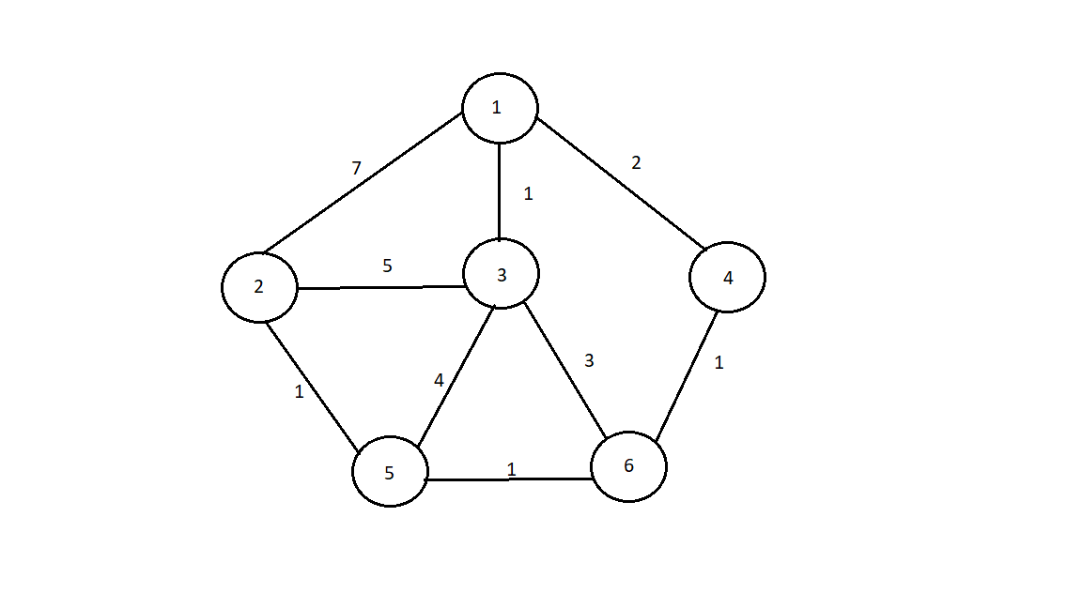

|  |  |  |  |
| --- | --- | --- | --- |
|  | $$σ uw$$ | $$σ uw(v)$$ | $$σ uw (v)/σ uw$$ |
| (1, 2) | 1 | 1 | 1 |
| (1, 3) | 1 | 0 | 0 |
| (1, 5) | 1 | 1 | 1 |
| (1, 6) | 1 | 1 | 1 |
| (2, 3) | 3 | 0 | 0 |
| (2, 5) | 1 | 0 | 0 |
| (2, 6) | 1 | 0 | 0 |
| (3, 5) | 2 | 0 | 0 |
| (3, 6) | 1 | 0 | 0 |
| (5, 6) | 1 | 0 | 0 |

Hence betweenness centrality of 4 is: 3

|  |  |  |  |
| --- | --- | --- | --- |
|  | $$σ uw$$ | $$σ uw(v)$$ | $$σ uw (v)/σ uw$$ |
| (1, 2) | 1 | 1 | 1 |
| (1, 3) | 1 | 0 | 0 |
| (1, 5) | 1 | 1 | 1 |
| (1, 4) | 1 | 0 | 0 |
| (2, 3) | 3 | 1 | 1/3 |
| (2, 5) | 1 | 0 | 0 |
| (2, 4) | 1 | 1 | 1 |
| (3, 5) | 2 | 1 | ½ |
| (3, 4) | 1 | 0 | 0 |
| (5, 4) | 1 | 1 | 1 |

Hence betweenness centrality of 6 is: 4.83

|  |  |  |  |
| --- | --- | --- | --- |
|  | $$σ uw$$ | $$σ uw(v)$$ | $$σ uw (v)/σ uw$$ |
| (1, 2) | 1 | 1 | 1 |
| (1, 3) | 1 | 0 | 0 |
| (1, 4) | 1 | 0 | 0 |
| (1, 6) | 1 | 0 | 0 |
| (2, 3) | 3 | 2 | 2/3 |
| (2, 4) | 1 | 1 | 1 |
| (2, 6) | 1 | 1 | 1 |
| (3, 4) | 1 | 0 | 0 |
| (3, 6) | 1 | 0 | 0 |
| (4, 6) | 1 | 0 | 0 |

Hence betweenness centrality of 5 is: 3.67

|  |  |  |  |
| --- | --- | --- | --- |
|  | $$σ uw$$ | $$σ uw(v)$$ | $$σ uw (v)/σ uw$$ |
| (1, 4) | 1 | 0 | 0 |
| (1, 3) | 1 | 0 | 0 |
| (1, 5) | 1 | 0 | 0 |
| (1, 6) | 1 | 0 | 0 |
| (4, 3) | 1 | 0 | 0 |
| (4, 5) | 1 | 0 | 0 |
| (4, 6) | 1 | 0 | 0 |
| (3, 5) | 2 | 0 | 0 |
| (3, 6) | 1 | 0 | 0 |
| (5, 6) | 1 | 0 | 0 |

Hence betweenness centrality of 2 is: 0

|  |  |  |  |
| --- | --- | --- | --- |
|  | $$σ uw$$ | $$σ uw(v)$$ | $$σ uw (v)/σ uw$$ |
| (1, 2) | 1 | 0 | 0 |
| (1, 4) | 1 | 0 | 0 |
| (1, 5) | 1 | 0 | 0 |
| (1, 6) | 1 | 0 | 0 |
| (2, 4) | 1 | 0 | 0 |
| (2, 5) | 1 | 0 | 0 |
| (2, 6) | 1 | 0 | 0 |
| (4, 5) | 2 | 0 | 0 |
| (4, 6) | 1 | 0 | 0 |
| (5, 6) | 1 | 0 | 0 |

Hence betweenness centrality of 3 is: 0

|  |  |  |  |
| --- | --- | --- | --- |
|  | $$σ uw$$ | $$σ uw(v)$$ | $$σ uw (v)/σ uw$$ |
| (4, 2) | 1 | 0 | 0 |
| (4, 3) | 1 | 1 | 1 |
| (4, 5) | 1 | 0 | 0 |
| (4, 6) | 1 | 0 | 0 |
| (2, 3) | 3 | 0 | 0 |
| (2, 5) | 1 | 0 | 0 |
| (2, 6) | 1 | 0 | 0 |
| (3, 5) | 2 | 0 | 0 |
| (3, 6) | 1 | 0 | 0 |
| (5, 6) | 1 | 0 | 0 |

Hence betweenness centrality of 1 is: 1

Maximum possible betweenness centrality for an undirected graph (M) is:  
(N-1)(N-2)/2 = (6-1)(6-2)/2 = 10

|  |  |  |
| --- | --- | --- |
| Vertex | Betweenness Centrality | Normalized BC ( = BC/M ) |
| 1 | 1 | 0.1 |
| 2 | 0 | 0 |
| 3 | 0 | 0 |
| 4 | 3 | 0.3 |
| 5 | 3.67 | 0.367 |
| 6 | 4.83 | 0.483 |